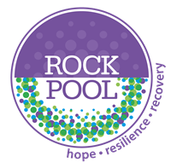
SPACE – Supporting Parents and Children Emotionally Insights
The Supporting Parents and Children Emotionally programme was created in 2020 to help parents understand their children’s emotions and how best to support them. It was piloted in Cornwall, and we soon discovered that we needed to develop a Children and Young Persons Programme to run alongside the Adult Programme. It is a universal programme that can be run in schools and family hubs.

Between January 2021 and February 2023, we have run 34 SPACE facilitator training courses.
We have trained over 430 delegates to deliver the SPACE programme.
8 organisations have commissioned us to provide our training course to their professionals.
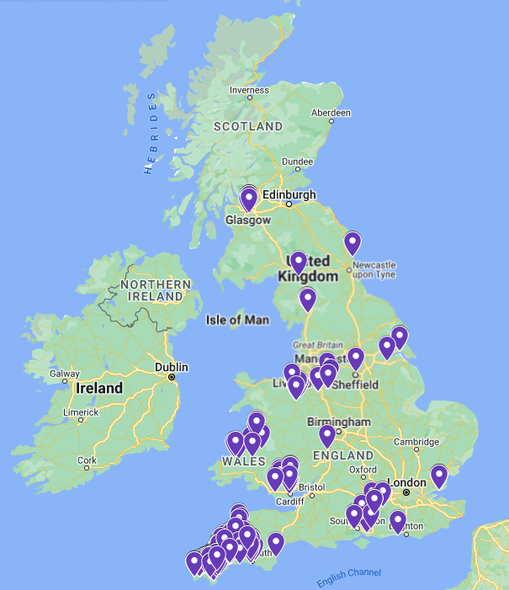
100% of the SPACE facilitator courses have been delivered online.
Below are some of the organisations who have commissioned us to deliver the SPACE – Supporting Parents and Children Emotionally facilitator training to their professionals.

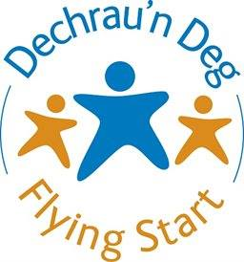

This map indicates where our facilitator training has taken place.
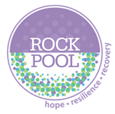
In January 2023, facilitators who completed the SPACE training between January 2021 and October 2022, were asked to provide feedback on the programme. The results of those who responded are below:

62% have already delivered the SPACE programme to either Adults and/or Children and Young People.
29% of facilitators are delivering the SPACE programme 4 times per year, with the remaining 71% delivering on a bi-annual, annual, or ad hoc basis.
The average starting group size is between 5 and 9 participants.
Facilitators report that an average on 81% of participants complete the full course.
8.7/10 was the average score when asked ‘Do you think that the SPACE programme has a positive impact for participants?’ (10 = Very positive 1= Very negative)
100% of facilitators feel the Toolkit is effective, with 93% of those finding it either Extremely or Very effective.
The training and the way it was presented made it very thought provoking, gave us lots of opportunities to interact and being able to see others present sessions really supported the understanding of sessions and what they will look like.
SPACE Facilitator

It’s really helped me understand my emotions when dealing with my child’s meltdowns. Thanks.
SPACE Participant

Very comprehensive and well-run training. The manuals and resources are well written and easy to follow.
SPACE Facilitator

This course is a great foundation. I think more people should do this course. it will help them understand themselves and their children.
SPACE Participant

I just thought the whole course was delivered so well and in a way that was accessible and interesting. Also, the resources are brilliant and having a go at delivering really built my confidence.
SPACE Facilitator

I think it's a very important course, and I wish for lots of other families to benefit from it.
SPACE Participant

