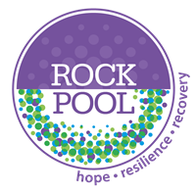
Domestic Abuse Recovery Toolkit Insights
The Domestic Abuse Recovery Toolkit Programme was created by Sue Penna in 2005 and is an evidence-based, trauma-informed psychoeducational model that focuses on recovery from the psychological impact of coercion & control.

Between January 2017 and February 2023, we have run 71 Domestic Abuse Recovery Toolkit facilitator training courses.
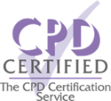
We have trained over 900 delegates to deliver the Domestic Abuse Recovery Toolkit.
30 organisations have commissioned us to provide our CPD accredited training course to their professionals.
54% of the courses have been delivered in person at various venues around the country. Since COVID, a further 46% have been delivered online.
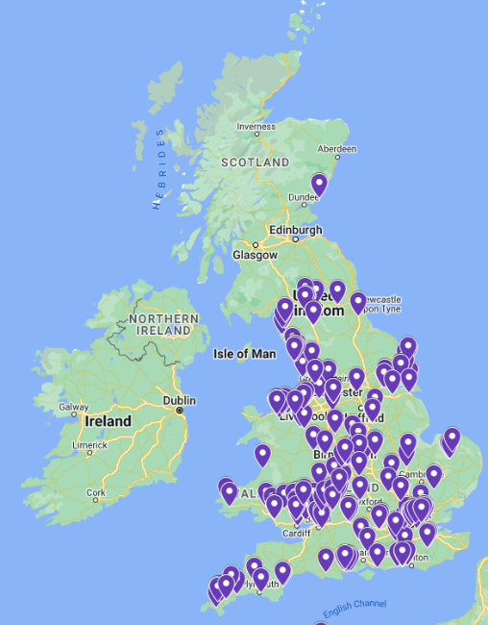
Below are some of the organisations who have commissioned us to deliver the Domestic Abuse Recovery Toolkit facilitator training to their professionals.

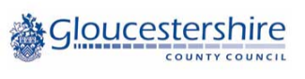
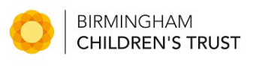
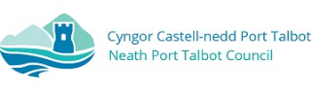
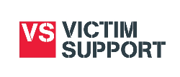

This map indicates where our facilitator training has taken place.
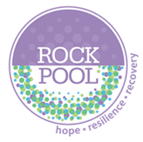
In September 2022, facilitators who completed the Domestic Abuse Recovery Toolkit training between September 2020 and September 2022, were asked to provide feedback on the Toolkit. The results of those who responded are below:

90% have already delivered the Toolkit to either Adults and/or Children and Young People.
Over 50% of facilitators are delivering the Toolkit 4 times per year.
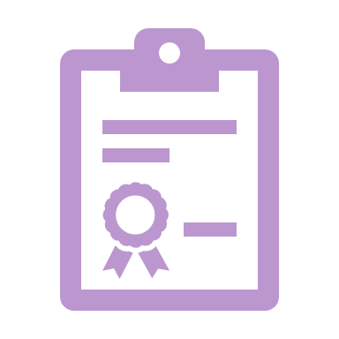
The average starting group size is between 5 and 9 participants.
Facilitators report that an average on 78% of participants complete the 12-week Toolkit.
8.9/10 was the average score when asked ‘Do you think that the Domestic Abuse Recovery Toolkit has a positive impact for participants?’ (10 = Very positive 1= Very negative)
100% of facilitators feel the Toolkit is effective, with 81% of those finding it either Extremely or Very effective.
The RTK has helped me realise how happy and beautiful I am. I don’t feel lonely or worthless anymore.
DA RTK Participant

The best training, I have attended in a long time. I feel confident following the training that I can provide a quality service for our families that will make a real difference to the outcomes.
DA RTK Facilitator

The course helps you grow into a better and more confident person.
DA RTK Participant

The resources that have been sent out are really well explained in all the books. The Recovery Toolkit by Sue Penna is so well written and to the point love it!!
DA RTK Facilitator

Really pleased with the sessions this has helped me with my confidence and self-esteem.
DA RTK Participant

The toolkit provided is excellent and will enable me to deliver the training and transferring awareness and learning to clients confidently and with clarity.
DA RTK Facilitator

