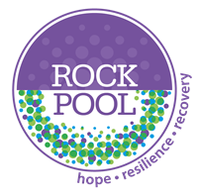
ACEs Recovery Toolkit Insights
The Adverse Childhood Experience Recovery Toolkit Programme was created by Sue Penna in 2017 and is an evidence based, trauma informed group programme based on a psychoeducational model and focuses on recovery from the psychological impact of Childhood Trauma.

Between November 2017 and February 2023, we have run 104 ACEs Recovery Toolkit training courses.
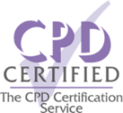
We have trained over 1300 delegates to deliver the ACEs Recovery Toolkit.
26 organisations have commissioned us to provide our CPD accredited training course to their professionals.
63% of the courses have been delivered in person at various venues around the country. Since COVID, a further 37% have been delivered online.
Below are some of the organisations who have commissioned us to deliver the ACEs Recovery Toolkit facilitator training to their professionals.
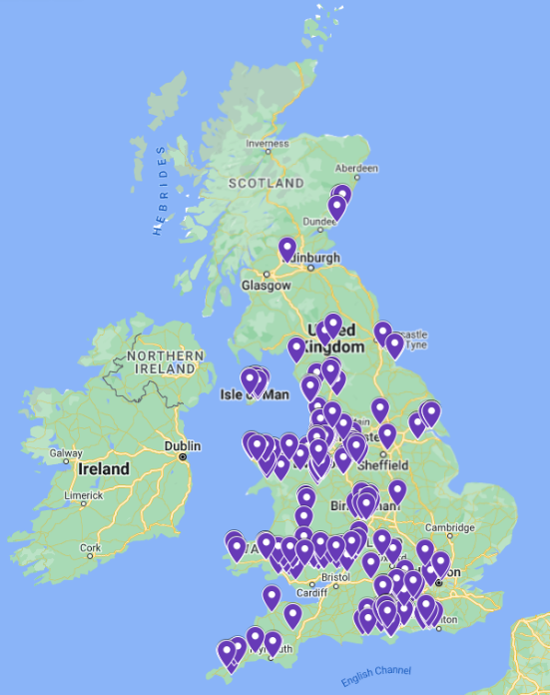

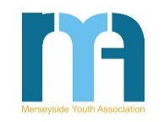
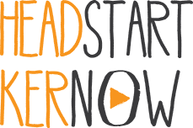

This map indicates where our facilitator training has taken place.
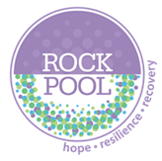
In October 2022, facilitators who completed the ACEs Recovery toolkit training between November 2017 and October 2022, were asked to provide feedback on the programme. The results of those who responded are below:

79% have already delivered the ACEs Recovery Toolkit to either Adults and/or Children and Young People.
31% of facilitators are delivering the Toolkit 4 times per year, with the remaining 69% delivering on a bi-annual, annual, or ad hoc basis.
The average starting group size is between 5 and 9 participants.
Facilitators report that an average on 78% of participants complete the full course.
8.9/10 was the average score when asked ‘Do you think that the ACEs Recovery Toolkit has a positive impact for participants?’ (10 = Very positive 1= Very negative)
100% of facilitators feel the Toolkit is effective, with 80% of those finding it either Extremely or Very effective.
I really feel this was one of the best training courses I have attended. I was initially concerned that a virtual course would feel long and laborious. How wrong could I be! It was interactive, engaging, and inspiring. I am hopeful that in the future I will be able to access further Rockpool training.
ACEs Facilitator

The course was fantastic, it helped so much.
ACEs Participant

The children said they loved the course.
ACEs CYP Facilitator

The resources are excellent, and the books are very clear for each session which is helpful.
ACEs Facilitator

The knowledge and expertise of presenters was such that they kept the course interesting and were able to offer information not learned on other ace courses.
ACEs Facilitator

The participant felt it has changed her life dramatically for the better.
ACEs Facilitator

