Factsheet Four:
A Nurturing Environment
Maintaining a sense of cultural identity
To help support you as you adjust to life in the UK, we have created a series of factsheets, designed to offer some support and strategies, whatever your situation, and are based on what we know about people’s responses to traumatic events and what can help.
These series of factsheets do not claim to have all the answers and solutions to the difficulties you may have been experiencing. They aim to provide you with information to help you understand your bodies normal responses to the experiences you have recently endured. They will provide you with some strategies to understand you and your children’s emotional responses and using the evidence we have from what can help recover from traumatic experiences, so that it becomes something you lived through not something that defines you and your family’s life forever. There are suggestions of activities you can do that will improve you and your family’s psychological safety.
Being safe emotionally and physically is the basic need all humans have. It is often something we take for granted. You have just experienced the unimaginable – all that was stable and consistent and safe in your life has been taken from you.
While you may now be physically safe, you and your children are having to come to terms with a new country, the loss of your home, maybe family, culture, possessions, pets, job, career, and numerous other personal losses.
You and your children may have witnessed sights beyond belief and been forced to make decisions never anticipated.
Most of what you feel emotionally can be viewed as normal reactions to extremely abnormal situations.
l difficult or avoid it, are unable to concentrate in class, become naughty, play truant and others
Being safe emotionally and physically is the basic need all humans have. It Is often something we take for granted.

Page 1
The aim of these factsheets is to give you some strategies to look after your children by looking after yourself. If you have ever flown on a plane, you may remember the air steward safety briefing – ‘in the event of loss of oxygen, a mask will drop down in front of you. PUT YOUR OWN MASK ON first before helping others’. In effect if you don’t, you will pass out before you can help anyone else. It’s the same in this crisis, to help your children you need to be able to look after your own emotional health and safety first.
This factsheet is focusing on how we create and maintain a nurturing environment for our children and ourselves during these changing times. A nurturing environment is one that gives children the security and opportunity to discover themselves and their world. In a nurturing environment families listen to each other and respond with care and support to each other’s changing needs. In these challenging times, aiming for a nurturing environment will help all family members cope better with the added stress and strain
We also know from the evidence that maintaining a sense of cultural identity can help people fleeing their country of origin to have a sense of connectedness and belonging at a time you feel most vulnerable and potentially isolated and lonely. It can also foster a nurturing community environment.
All the topics we have covered so far – safety, connectedness and resilience will all help to build a nurturing environment.

The love and care wheels on the next pages are a great way to start to do this together as a family.
Have a look at the first wheel. How many of the sections can you complete? Ask your child to help you. You can even do this activity with older children and get their feedback on how they think you are doing!
The next wheel is for you to complete yourself and maybe with your partner to see how you are doing to nurture and support each other.

Page 2
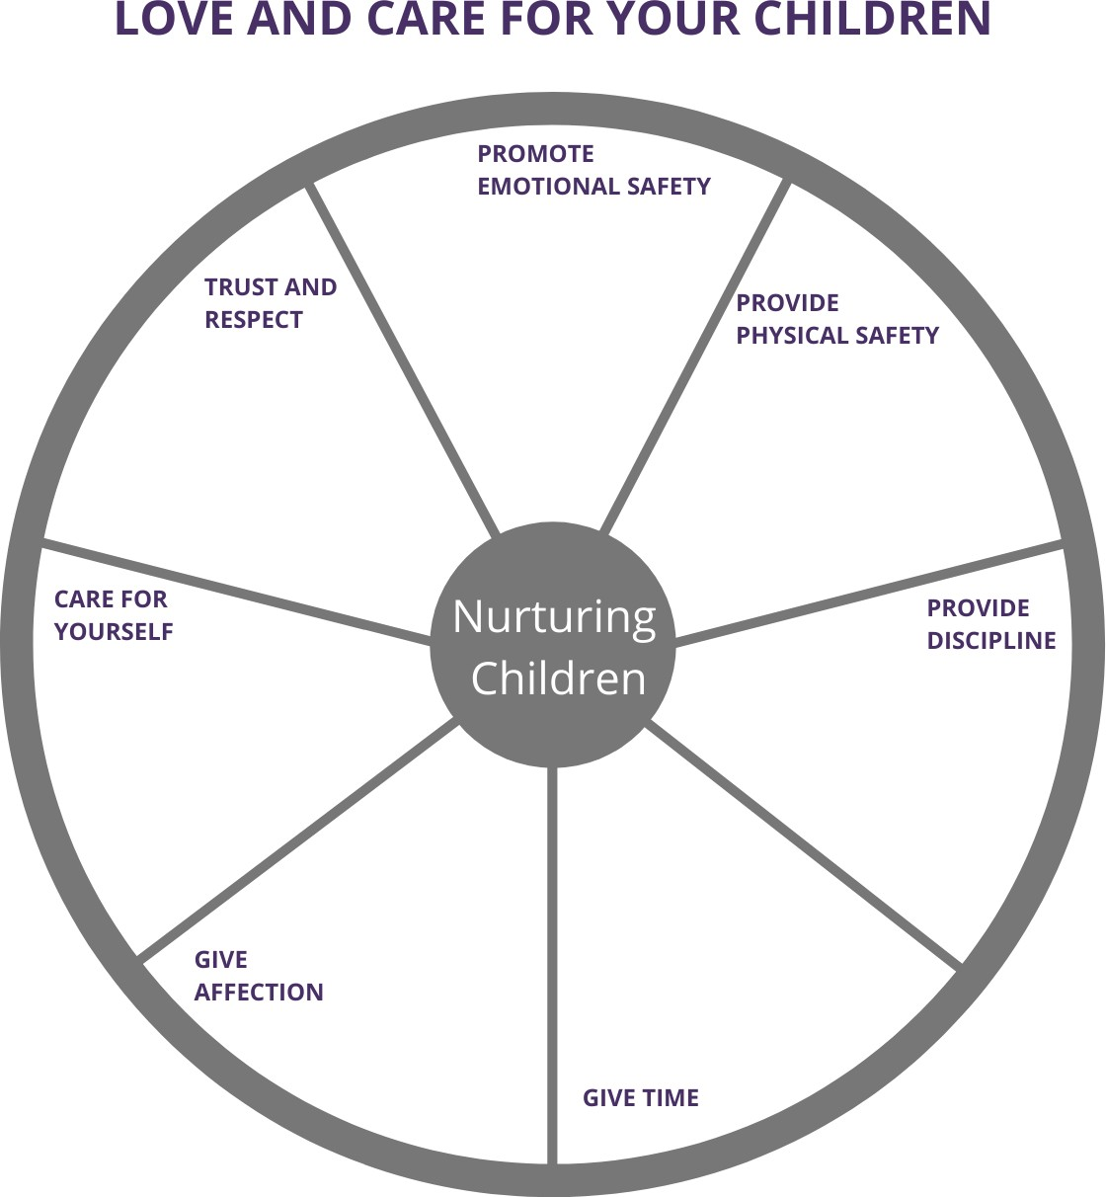

Page 3
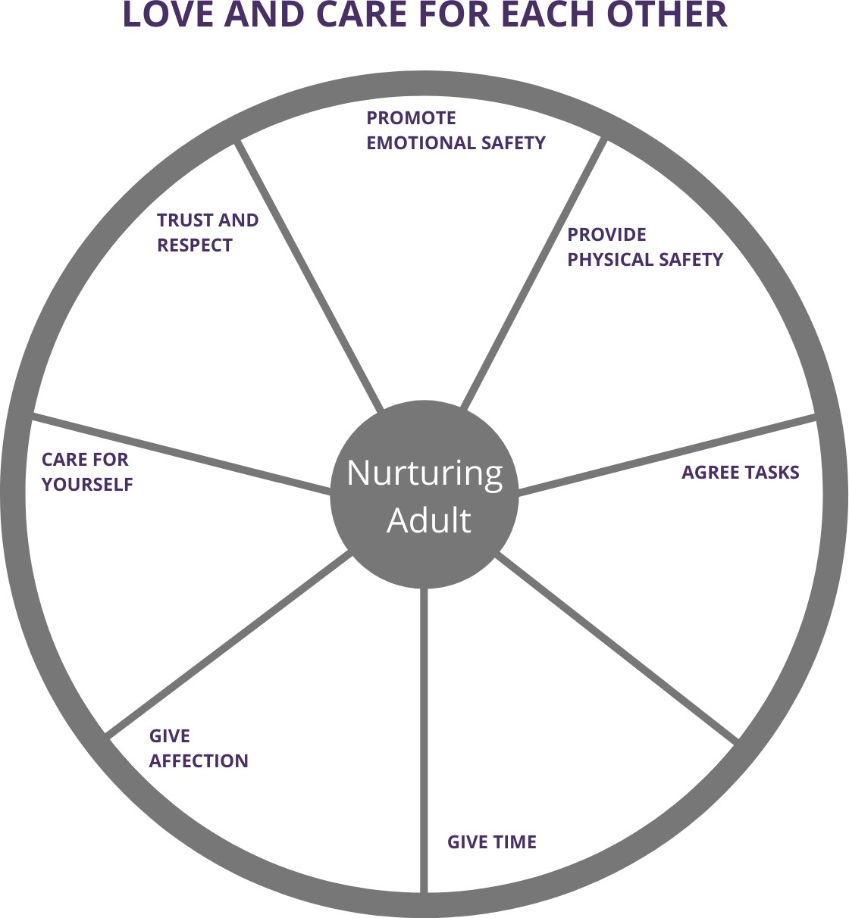

Page 4
It can be difficult when you are struggling to manage our own trauma to make time for each other. As well as coming to terms with your recent traumatic experiences you are having to come to term with living in a new country, maybe in someone’s else house, having no certainty about your future, experiencing language and communication difficulties, worrying about money and food and maybe other concerns not listed.
The next couple of exercises ask you to think about how you might plan to take part in activities with your children and yourself as a way of continuing to promote post trauma connectedness, resilience, and a nurturing environment
You can identify activities that connect yourself and your children to your own culture - when completing the form keep them to the here and now, what is happening currently and not things that happened before you arrived in the UK.
Child Activity Planner
Page 5
The activity I chose with my child was:

This week, the things I felt good about as a parent were:

The things my child and I did together were (be specific):

The things I praised my child for were:

The things I found difficult were:

Things I regret were:

Adult Activity Planner
The activity I chose was:

This week, the things I felt good about as an adult were:

The things I did for me, were (be specific):

The things I praised myself about were:

The things I found difficult were:

Things I regret were:

Page 6
Another exercise you can all do together is sharing how you are spending your time. There is a real chance here to check out that your family’s daily lifestyle is balanced and that you are able to see if there are routines and regular activities that promote safety and connectedness. An activity the whole family can do to help this is MATCHING THE PIES.
All the family draw a circle and then divide the sections into Pie slices to indicate how they are spending the day. Share this together and see if peoples pie slices are similar or hugely different, can you match any? There is opportunity then to negotiate appropriate time to have a balance of activity. One of the slices may also need to be shared time, like sitting at the table to eat, or play a game together, activities that can promote connectedness and culture identity.
For example: Green is sleeping, orange is schoolwork, purple is eating together, yellow is doing chores.

Page 7
Another activity for the whole family which encompasses – safety, connectedness and resilience is making a hand picture.
Every member of the family draws around their hand. Using color paper or card but alternatively just color the hand in once you have drawn around it.

Each person writes their name on their hand and then cuts out the shape. You then layer the hands-on top of one another, so the names are readable and stick together and mount it on a larger piece of paper. You can then label it ‘how we are together’ and ask each member of the family to write something positive about being in the UK at the moment.

This week’s factsheet has focused on the need to nurture our family and therefore reinforcing, safety, connectedness, resilience, and cultural identity.
Page 8

